Bahria University,

Karachi Campus



LAB EXPERIMENT NO.

02

LIST OF TASKS

|  |  |
| --- | --- |
| TASK NO. | OBJECTIVE |
| 1 | Design a multiple webpages including html & CSS. Include all the CSS properties of text, border font etc. The following navigation tabs must be added:   1. Home (Give info about what your website is about) 2. Information (Include the detailed information related to the particular technology) 3. Gallery (Include images and Videos of technology) 4. About (Give the information about yourself) |
| 2 | Write a CSS rule that makes all text 1.5 times larger than the base font of the system and colors the text red. |
| 3 | Write a CSS rule that places a background image halfway down the page, tiling it horizontally. The image should remain in place when the user scrolls up or down. |
| 4 | Write a CSS rule that gives all h1 and h2 elements a padding of 0.5 ems, a dashed border style and a margin of 0.5 ems. |
| 5 | Add an embedded style sheet to the HTML5 document in the given figure. The style sheet should contain a rule that displays h1 elements in blue. In addition, create a rule that displays all links in blue without underlining them. When the mouse hovers over a link, change the link’s background color to yellow. |

|  |  |
| --- | --- |
| 6 | Make a navigation button using a div with a link inside it. Give it a border, background, and text color, and make them change when the user hovers the mouse over the button. Use an external style sheet. |

Submitted On:

**Task 1:** Design a multiple webpages including html & CSS. Include all the CSS properties of text, border font etc. The following navigation tabs must be added:

1. Home (Give info about what your website is about)
2. Information (Include the detailed information related to the particular technology)
3. Gallery (Include images and Videos of technology)
4. About (Give the information about yourself)

**Solution:**

Index.html:

Style.css:

**Output:**

**Task 2:** Write a CSS rule that makes all text 1.5 times larger than the base font of the system and colors the text red.

**Solution:**

Index.html:

<!DOCTYPE html>

<html lang="en">

<head>

<meta charset="UTF-8">

<meta http-equiv="X-UA-Compatible" content="IE=edge">

<meta name="viewport" content="width=device-width, initial-scale=1.0">

<link rel="stylesheet" href="/CSS/style.css">

<title>Task 02</title>

</head>

<body>

<div class="container">

<div class="text1">

<h3>Before Changing Font Size and Color: </h3>

<p class="before-text">Lorem, ipsum dolor sit amet consectetur adipisicing elit. Aut nihil placeat architecto dolores commodi veniam culpa optio, deserunt molestias tempora ullam numquam adipisci, aliquam velit eaque? Dolores sapiente voluptate, impedit suscipit adipisci neque a aliquam cum optio numquam! Quod architecto possimus nisi placeat nobis nihil praesentium incidunt magni pariatur nesciunt delectus iure rerum, porro amet natus ratione id. Quis deleniti debitis, assumenda alias nam aliquid cum cupiditate delectus repellendus totam minus eum nisi voluptatibus molestiae at, ad, praesentium voluptatum nobis?</p>

</div>

<div class="text2">

<h3>After Changing Font Size (1.5 rems) and Color: </h3>

<p class="after-text">Lorem, ipsum dolor sit amet consectetur adipisicing elit. Aut nihil placeat architecto dolores commodi veniam culpa optio, deserunt molestias tempora ullam numquam adipisci, aliquam velit eaque? Dolores sapiente voluptate, impedit suscipit adipisci neque a aliquam cum optio numquam! Quod architecto possimus nisi placeat nobis nihil praesentium incidunt magni pariatur nesciunt delectus iure rerum, porro amet natus ratione id. Quis deleniti debitis, assumenda alias nam aliquid cum cupiditate delectus repellendus totam minus eum nisi voluptatibus molestiae at, ad, praesentium voluptatum nobis?</p>

</div>

</div>

</body>

</html>

Style.css:

@import url('https://fonts.googleapis.com/css2?family=Raleway&display=swap');

@import url('https://fonts.googleapis.com/css2?family=Metrophobic&display=swap');

*{

margin: 0;

padding: 0;

box-sizing: border-box;

}

body{

height: 100vh;

overflow: hidden;

}

h3{

font-family: 'Metrophobic', sans-serif;

font-size: 20px;

margin: 20px 80px;

}

p{

font-family: 'Raleway', sans-serif;

margin: 20px 80px;

}

.container{

position: relative;

top: 50px;

padding: 20px;

}

.text2{

margin-top: 40px;

}

.before-text{

line-height: 1.3;

}

.after-text{

font-size: 1.5rem;

color: red;

}

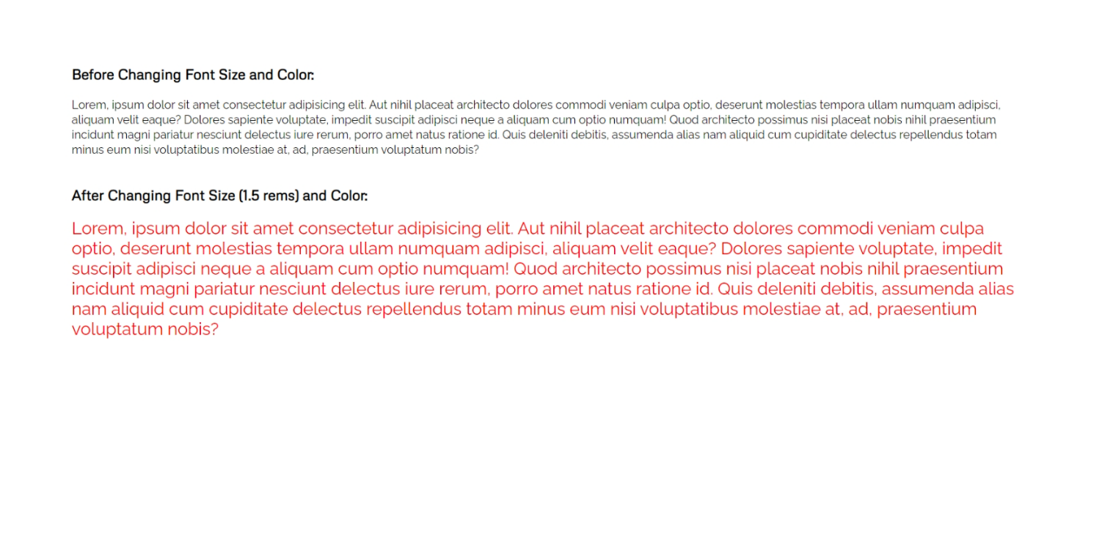**Output:**

**Task 3:** Write a CSS rule that places a background image halfway down the page, tiling it horizontally. The image should remain in place when the user scrolls up or down.

**Solution:**

Index.html:

<!DOCTYPE html>

<html lang="en">

<head>

<meta charset="UTF-8">

<meta http-equiv="X-UA-Compatible" content="IE=edge">

<meta name="viewport" content="width=device-width, initial-scale=1.0">

<link rel="stylesheet" href="/CSS/style.css">

<title>Task 03</title>

</head>

<body>

<div class="start"><h3>Start</h3></div>

<div class="container">

<header>

<h3>Background</h3>

</header>

</div>

<div class="end"><h3>End</h3></div>

</body>

</html>

Style.css:

@import url('https://fonts.googleapis.com/css2?family=Raleway&display=swap');

@import url('https://fonts.googleapis.com/css2?family=Metrophobic&display=swap');

*{

margin: 0;

padding: 0;

box-sizing: border-box;

}

body{

height: 200vh;

overflow-x: hidden;

}

header h3{

font-family: 'Metrophobic', sans-serif;

font-size: 27px;

color: #fff;

position: absolute;

top: 80px;

left: 80px;

text-decoration: underline;

}

.container{

position: relative;

top: 25%;

height: 100vh;

width: 100%;

background-image: url(/Images/bg.jpg);

background-size: cover;

background-repeat: no-repeat;

background-attachment: scroll;

background-position: center;

}

.start h3{

font-family: 'Metrophobic', sans-serif;

font-size: 27px;

text-decoration: underline;

position: absolute;

top: 50px;

left: 80px;

}

.end h3{

font-family: 'Metrophobic', sans-serif;

font-size: 27px;

text-decoration: underline;

position: relative;

top: 480px;

left: 80px;

}

**Output:**

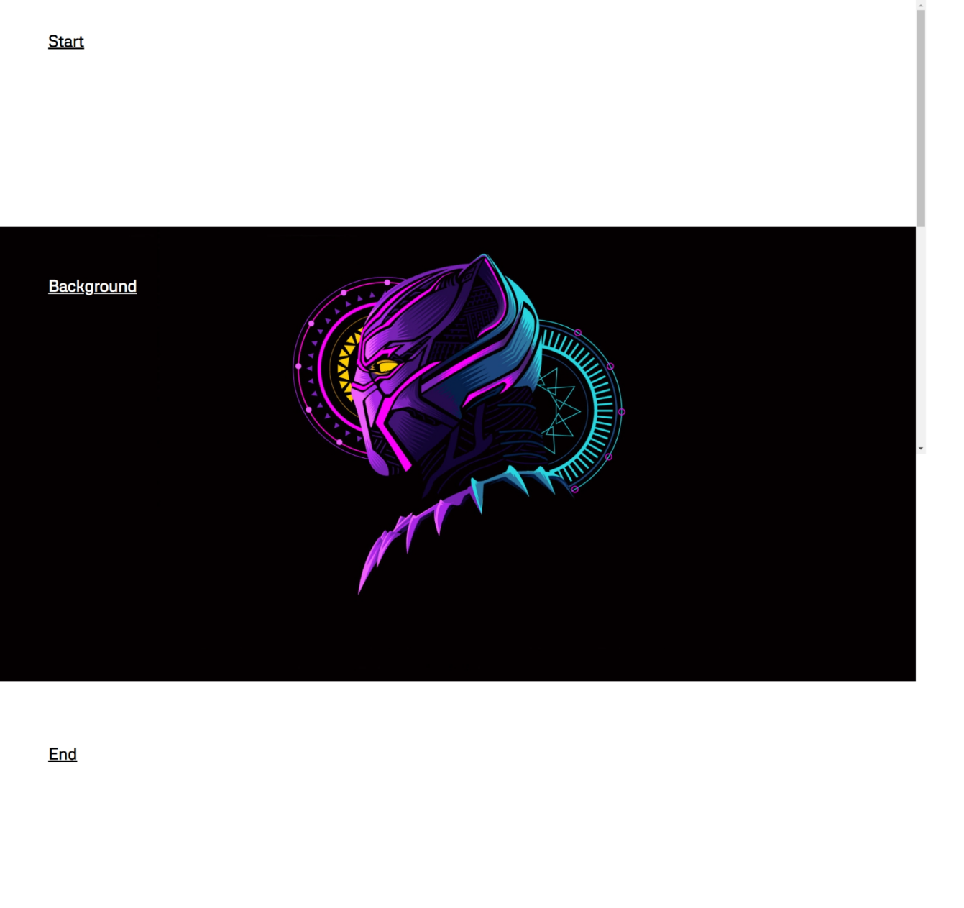

**Task 4:** Write a CSS rule that gives all h1 and h2 elements a padding of 0.5 ems, a dashed border style and a margin of 0.5 ems.

**Solution:**

Index.html:

<!DOCTYPE html>

<html lang="en">

<head>

<meta charset="UTF-8">

<meta http-equiv="X-UA-Compatible" content="IE=edge">

<meta name="viewport" content="width=device-width, initial-scale=1.0">

<link rel="stylesheet" href="/CSS/style.css">

<title>Task 04</title>

</head>

<body>

<div class="container">

<h1>This is Heading 'h1'</h1>

<h2>This is Heading 'h2'</h2>

</div>

</body>

</html>

Style.css:

@import url('https://fonts.googleapis.com/css2?family=Metrophobic&display=swap');

*{

margin: 0;

padding: 0;

box-sizing: border-box;

}

body{

height: 100vh;

overflow: hidden;

}

h1, h2{

font-family: 'Metrophobic', sans-serif;

padding: 0.5em;

border: 1px dashed #1b1b1b;

margin: 0.5em;

}

.container{

margin-top: 55px;

}

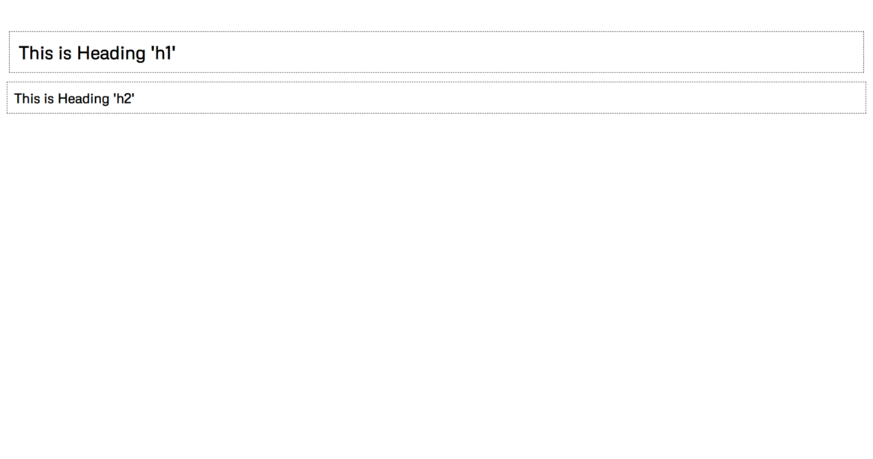**Output:**

**Task 5:** Add an embedded style sheet to the HTML5 document in the below figure. The style sheet should contain a rule that displays h1 elements in blue. In addition, create a rule that displays all links in blue without underlining them. When the mouse hovers over a link, change the link’s background color to yellow.



**Solution:**

Index.html:

<!DOCTYPE html>

<html lang="en">

<head>

<meta charset="UTF-8">

<meta http-equiv="X-UA-Compatible" content="IE=edge">

<meta name="viewport" content="width=device-width, initial-scale=1.0">

<link rel="stylesheet" href="/CSS/style.css">

<title>Task 05</title>

</head>

<body>

<div class="container">

<h1>Here are my favorite sites:</h1>

<h3>Click a name to visit that site.</h3>

<nav>

<ul style="list-style-type: none;">

<li><a href="www.facebook.com">Facebook</a></li>

<li><a href="www.twitter.com">Twitter</a></li>

<li><a href="www.foursquare.com">Foursquare</a></li>

<li><a href="www.google.com">Google</a></li>

</ul>

</nav>

</div>

</body>

</html>

Style.css:

@import url('https://fonts.googleapis.com/css2?family=Raleway&display=swap');

@import url('https://fonts.googleapis.com/css2?family=Metrophobic&display=swap');

*{

margin: 0;

padding: 0;

box-sizing: border-box;

}

body{

height: 100vh;

overflow: hidden;

}

.container{

padding: 60px 80px;

}

h1{

font-family: 'Metrophobic',sans-serif;

font-size: 25px;

color: blue;

}

h3{

font-family: 'Metrophobic',sans-serif;

margin-top: 13px;

margin-bottom: 15px;

}

nav ul li{

padding: 7px 0;

}

nav ul li a{

font-family: 'Raleway', sans-serif;

font-size: 16px;

color: blue;

font-weight: 500;

text-decoration: none;

}

nav ul li a:hover{

background-color: yellow;

padding: 3px;

}

**Output:**

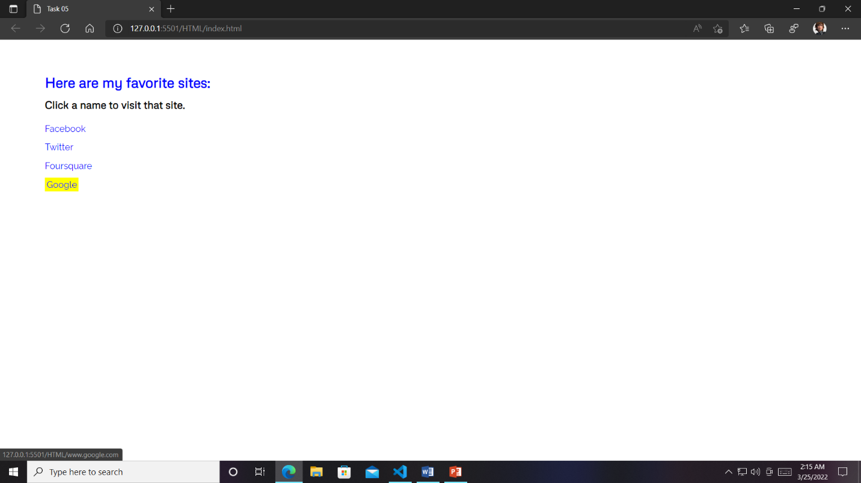

**Task 6:** Make a navigation button using a div with a link inside it. Give it a border, background, and text color, and make them change when the user hovers the mouse over the button. Use an external style sheet.

**Solution:**

Index.html:

<!DOCTYPE html>

<html lang="en">

<head>

<meta charset="UTF-8">

<meta http-equiv="X-UA-Compatible" content="IE=edge">

<meta name="viewport" content="width=device-width, initial-scale=1.0">

<link rel="stylesheet" href="/CSS/style.css">

<title>Task 06</title>

</head>

<body>

<div class="container">

<h3>Navigation Button:</h3>

<div class="nav-button">

<a href="www.facebook.com">Facebook</a>

</div>

</div>

</body>

</html>

Style.css:

@import url('https://fonts.googleapis.com/css2?family=Raleway&display=swap');

@import url('https://fonts.googleapis.com/css2?family=Metrophobic&display=swap');

*{

margin: 0;

padding: 0;

box-sizing: border-box;

}

body{

height: 100vh;

overflow: hidden;

}

.container{

margin: 70px 120px;

}

h3{

font-family: 'Metrophobic', sans-serif;

font-size: 23px;

margin-bottom: 50px;

text-decoration: underline;

}

.nav-button a{

font-family: 'Raleway', sans-serif;

font-size: 15px;

font-weight: 600;

color: #fff;

text-decoration: none;

border: 1px solid #1f1f1f;

border-radius: 5px;

background-color: darkblue;

padding: 10px 12px;

letter-spacing: 0.5px;

}

.nav-button a:hover{

color: black;

background-color: rgb(51, 255, 0);

border: 1px dashed #1f1f1f;

}

**Output:**





